Comerica Bank Covid-19 Response

Assignment 2

Genna Dankis, Andi Shahinllari, Allen Whaley, Skyler Lester

Executive Summary

Comerica Bank currently operates mainly in Texas, California, and Michigan. There are also other states with select business operations as well as Canada and Mexico. For Comerica Bank's risk analysis for the effects and strategy for Covid-19 the focus will be on their main locations that account for over 80% of their loans (main operating states are the main geographic regions used on the 10-K).[1] In 2019 about 55% of the banks earning assets were in the form of loans and leases. Loans past due 30-89 days were at $127 million and 90 days past due were at $26 million as of December 31, 2019.[2] The bank also had a provision for losses ratio of 0.10% in 2019 which was average compared to previous years.

Since businesses are shutting down and only a small percentage of people immediately have the ability to work from home it is very likely that many customers will lose income for at least 4 weeks. With that being said many businesses will likely have to cut costs to make up for the lack of revenue with less disposable income available to the consumer. The quickest way to cut costs will likely be to continue laying employees off. The maximum weekly benefits of state unemployment checks per week is; Michigan $362, California $450, and Texas $535.[3] If the government does not step in and increase weeks of unemployment and amount of unemployment many customers will have to default on their loans. Residential mortgages loans and consumer loans account for 8.5% of the bank's loans as of September 30, 2019.

About 64% of the bank's loans are commercial loans.These loans are short term loans provided for businesses. This type of loan creates the largest risk for default as well as loss of business for the bank in the future. Michigan, California and Texas hold the largest amount of loans at the bank accounting for 82%.[4] These markets are the most at risk for affecting the bank's portfolio and will be the main focus of the strategy the bank uses moving forward. With that being said it will be suggested to at minimum quadruple the provision for losses for the year 2020.

The main geographic region that Comerica Bank operates in saw mostly an increase during Q1 of 2020 in per capita income: Michigan 2.6%, California 6.1%, and Texas -0.6%.[5] The increase in revenue would decrease a person's risk of default when borrowing from the bank. This area also saw a large decrease in employment: Michigan -7.8%, California -6.1%, and Texas -4.2%.[6] (Although these numbers were for the entire year of 2020 the most drastic changes happened at the very start of the pandemic. There would have been similar or greater numbers for Q1and Q2 of 2020 since the largest shift in work happened during the first lockdowns). The large number of people that become unemployed would increase the risk of default.

Below is a graph representing the dollar amount of loans past due 30-89 days and 90 days between the years 2015-2019.[7] In the graph it is shown that loans past due 90 days have stayed relatively stable even during economic hardships. For 30-89 days past due there is a large spike in 2017.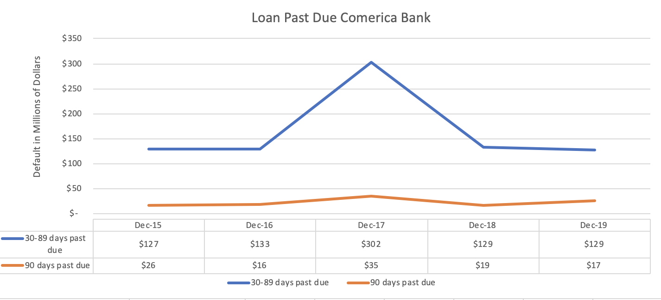

At the end of August hurricane Harvey hit Texas and affected not only their economy but also the rest of the United States. Shortly after that hurricane Irma hit Florida in September having similar effects.[8] This in turn could create loss of product and revenue for businesses in and outside of these two states, delays of payments for B2B sales, loss of jobs, homes, food and essential needs. Although these natural disasters are very different from the pandemic they are similar in the way they shift the economy based on jobs, housing, feelings of security, banking needs and so on. Between 2016 - 2017, 30-89 day past due increased by 44% and it is expected to see similar increases during the pandemic. This is reflected in the suggestion to at a minimum quadruple the provision for losses during 2020 to 0.40%.

Response

A customer impacted by Covid-19 can be defined as a loss in; job, customers, business, family, and essential needs. Comerica bank so far has taken actions to protect mainly business loans and consumer loan repayments. In February 2020 the Coronavirus Aid, Relief, and Economic Security Act or the CARES Act authorized the U.S Small Business Administration (SBA) to Paycheck Protection (PPP), a lending plan to provide loans to small businesses to help keep employees on payroll. This would be for the time of February 15, 2020 through June 30, 2020[9]. Comerica Bank’s goal is to process upward of 13,0000 applications with around $4.1 billion expected to be funded for these loans.[10] This funding is to be focused in California, Michigan and Texas. On top of this Comerica also plans on lowering interest for Economic Injury Disaster Loans. These loans are also part of the SBA and were created to help small businesses through temporary loss of revenue. For private consumer protection the bank focused on eliminating late payments and overdraft fees, and loan forbearance and deferrals.[11]

Comerica believes that the current remedies available are the best way to ensure protection of the bank while fully aiding and supporting their customers. Since many businesses will be receiving new capital from Comerica Bank it is important that these businesses are only placed on forbearance for a short time and have the ability to pay back the paused payments. When businesses ask for forbearance or deferral of a loan the bank must deeply analyze the need/length of this paused period and analyze when they will likely receive the entirety of the payments. If the bank can maintain a steady forbearance of businesses it will allow more room for private customers to receive the aid listed above. The pros of focusing on helping businesses first will have a trickle down effect on the private customers. It will help ensure that private customers have more opportunity to stay employed which will help less private customers defer payments. This will also in turn help businesses stay open since capital will be circling in the economy. The cons of this is it will take a large amount of time and assets for the bank to analyze distribution of assets and forbearance and deferral allotment to ensure the safety of the bank and their customers.

Other banks have responded similarly to Comerica Bank. Most of the focus for these banks were protecting paychecks with the Paycheck Protection Plan (PPP). Since most banks' income comes from local businesses it is important for banks to ensure their longevity through the pandemic. That is why the first step during lockdowns was to protect these businesses in the form of PPP and small business loans[12] For customers similar to Comerica the focus was on reducing or eliminating overdraft fees, eliminating late payments, and loan deferrals.

On March 26, 2020 the Federal Reserve lowered the reserve ratio to 0[13]. This was in hopes that banks could use additional liquidity to lend to businesses or private customers. Doing this would help stabilize or increase the economy during the pandemic. Since the bank will be using their extra liquidity to aid current businesses and private customers it will be much riker for the bank to tolerate new business loans. To increase cash reserves the bank will need to focus on properly planning out the year of 2020 and factoring in extra risk when aiding customers. Any new loans should focus on aiding current businesses with paycheck protection and loans to help keep their businesses open.Since the reserve ratio is 0 the bank still needs to ensure that they still have assets available to their private customers. The bank should utilize the Comerica Contributions Department to help provide aid to as many businesses as possible allowing the bank to hold on to more of their reserves to help private customers and supply capital to PPP loans. Since the bank is FDIC insured, depositors will be protected at the end of the day.

Strategy

The response strategy should be created by a national team but managed by local branches that specialize in Covid-19 related questions, problems and solutions. It is important to have one national team to create a plan of action based on different economic factors like average income in the state, average unemployment in the state, average home prices in the state and so on. The national team will then be able to train local branches on guidelines and solutions. Using local branches will allow the bank to save money and time on hiring new employees, purchasing new technology, and training new employees. Having a national team to create guidelines will allow the bank to give concise information on their website, emails, social media, and other advertisements.

The biggest issues in implementing this strategy would be providing enough funding to help customers that are in need. Through the Comerica Contributions Department, the bank provides monetary support to non-profit charitable organizations. This is made possible through grants[14]. Comerica Bank should contact current and past supporters for these grants to create new grants to offer to businesses that may qualify for PPP loans during Covid. By providing grants, the bank could eliminate some loans that they might have to provide to their customers, lowering the amount of risk they will be taking on. Since this will only be a small amount compared to the number of customers that are affected, it is important that the bank works to make banking easy for customers to ensure they are still receiving some type of revenue during operation.

Conclusion

Comerica Bank is focused on providing aid for their customers while also managing their risk through the pandemic. It is expected to see a large increase in loan deferment similar/worse to times of natural disasters. Comerica bank is suggesting increasing at a minimum the provision for losses to 0.40% during 2020. This will help the bank analyze their risk and help

make better decisions when aiding customers through the pandemic. The main aid that

Comerica Bank is focused on the Paycheck Protection Plan (PPP), lowering interest for Economic Injury Disaster Loans, eliminating late payments and overdraft fees, and loan forbearance and deferrals. By focusing on businesses first Comerica is ensuring greater security in jobs for private customers and a flow of capital in the economy. This will help less private customers need aid from the bank allowing Comerica to focus their aid on the riskier and larger group of loans for businesses. To manage distribution of information to customers Comerica will use a national team to set up guidelines for receiving help that local branches can then distribute to their customers. Comerica is dedicated to finding new ways to raise capital to increase their ability to help their customers while managing their risk. The bank hopes to use the Comerica Contributions Department as a way to raise money for businesses during the pandemic.

References

1. *Comerica Bank Customer Success Stories: PPP Loans. Comerica Bank. (n.d.). Retrieved March 12, 2022, from https://www.comerica.com/insights/business-finance/customer-success-stories-ppp-loans.html*
2. *Company overview - comerica. Comerica Bank. (n.d.). Retrieved March 12, 2022, from https://www.comerica.com/about-us/company-overview.html*
3. *Diversity commitment | comerica. (n.d.). Retrieved March 19, 2022, from https://www.comerica.com/about-us/corporate-responsibility/corporate-responsibility-information/diversity-commitment.html?_ga=2.19201851.2096414629.1640715050-705703567.1640715050*
4. *The economic situation, December 2017. Mercatus Center. (2020, October 30). Retrieved March 15, 2022, from https://www.mercatus.org/publications/regulation/economic-situation-december-2017*
5. *Foreman, D. (2021, June 21). 6 months in: How banks and bankers are responding to covid-19 . Forbes. Retrieved March 19, 2022, from https://www.forbes.com/advisor/banking/6-months-in-how-banks-and-bankers-are-responding-to-covid-19/*
6. *H.R.748 - 116th congress (2019-2020): Cares act | congress ... (n.d.). Retrieved March 19, 2022, from https://www.congress.gov/bill/116th-congress/house-bill/748*
7. *Personal covid-19 recovery - comerica. Personal Banking-Covid-19. (n.d.). Retrieved March 15, 2022, from https://www.comerica.com/campaigns/covid-19/personal.html*
8. *SEC filings. Comerica Investors. (2019, October 30). Retrieved March 12, 2022, from* [*https://investor.comerica.com/sec-filings?year=2020*](https://investor.comerica.com/sec-filings?year=2020)
9. *Reserve Requirements . Board of governors of the Federal Reserve System. (n.d.). Retrieved March 27, 2022, from https://www.federalreserve.gov/monetarypolicy/reservereq.htm#:~:text=As%20announced%20on%20March%2015,requirements%20for%20all%20depository%20institutions.*
10. *SEC filings. Comerica Investors. (n.d.). Retrieved March 15, 2022, from https://investor.comerica.com/sec-filings?o=50&year=2019*
11. *SEC filings. Comerica Investors. (n.d.). Retrieved March 15, 2022, from https://investor.comerica.com/sec-filings?o=50&year=2019*
12. *Sign in register help E-mail address password register forgot your password? E-mail address password verify password sign in forgot your password? E-mail address sign in register regional data GDP and personal income mapping. BEA. (n.d.). Retrieved March 12, 2022, from https://apps.bea.gov/iTable/iTable.cfm?reqid=99&step=1*
13. *Unemployment benefits comparison by state. FileUnemployment. (2021, May 26). Retrieved March 12, 2022, from https://fileunemployment.org/unemployment-benefits-comparison-by-state*

1. *SEC filings*. Comerica Investors. (2020, February 12).
2. *SEC filings*. Comerica Investors. (2019, October 30).
3. *Unemployment benefits comparison by state*. FileUnemployment. (2021, May 26).
4. *SEC filings*. Comerica Investors. (2019, October 30).
5. *Regional data GDP and personal income mapping*. BEA.
6. *Regional data GDP and personal income mapping*. BEA.
7. *SEC filings*. Comerica Investors. (2015-2019).
8. *The economic situation, December 2017*. Mercatus Center. (2020, October 30).
9. *H.R.748 - 116th congress (2019-2020): Cares act | congress.*
10. *Comerica Bank Customer Success Stories: PPP Loans*. Comerica Bank.
11. *Personal covid-19 recovery - comerica*. Personal Banking-Covid-19.
12. *6 months in: How banks and bankers are responding to covid-19* . Forbes.
13. *Reserve Requirements . Board of governors of the Federal Reserve System.*
14. *Diversity commitment | comerica*.